KISII UNIVERSITY
A Final Year PROJECT PROPOSAL ON
Applying computer vision In Brain Tumour
Classification for Effective Diagnosis
SUBMITTED IN PARTIAL FULFILLMENT OF THE REQUIREMENTS FOR THE DEGREE OF
BACHELOR OF SCIENCE IN COMPUTER SCIENCE
By
Abel Kiprotich Rono IN13/00026/20

Acknowledgement.
We highly appreciate the department of computing sciences for believing in our potential. We thank the head of department specifically for taking us through this unit of project development. This is a great motivation for us as we prepare for the outside world.



Table of contents.
Contents
LIST OF TABLES v
Acknowledgement……………………………………………………………………………v
Declaration………………………………………………………………………………….vi
ABSTRACT vii
CHAPTER ONE 1
1.1 Background Information 1
1.2 Problem statement 1
1.3 Main Objectives 2
1.3.1 Specific objectives 2
1.4 Significance of the Study 2
1.5 Scope of the Study 2
CHAPTER TWO 3
2 LITERATURE REVIEW 3
2.1 INTRODUCTION 3
2.2 Previous approaches 3
2.3 Limitation of the Previous Approaches. 6
CHAPTER THREE 9
3 METHODOLOGY 9
3.1 Flowchart. 9
3.2 Dataset 10
3.3 Data pre-processing 10
3.3.1 Image acquisition 10
3.3.2 Image de-noising. 10
3.3.3 Histogram Equalization. 11
3.4 Classification of Algorithms 12
3.4.1 You Look Only Once (YOLOv8). 12
3.5 Evaluation metrics. 16
3.6 Quantitative and Qualitative analysis 16
3.6.1. Quantitative Analysis. 16
3.6.2 Qualitative analysis. 17
Chapter 4 18
4.1 System design and Analysis. 18
4.1.1 Use cases. 18
4.2.1 Class diagram. 18
4.2 Tool and software requirements. 18
4.3 Functional and non-functional requirements. 19
4.4 System Design 19
4.4.1 System Architecture. 19
4.4.2 Database Design 20
4.4.3 Input Output interface 21
Chapter 5 22
5.1System implementation Testing and Validation. 22
Chapter 6 33
6.0 Summary, Conclusions and Recommendation. 33
6.1 Summary. 33

LIST OF TABLES
Table 1 7

ABSTRACT
This project proposal outlines the development of an advanced artificial intelligence (AI) system for the comprehensive detection, segmentation and classification of brain tumours from medical imaging data. Brain tumour pose a significant threat to human health and timely and accurate diagnosis is crucial for effective treatment. Traditional methods for brain tumours analysis are time consuming and often rely on subjective interpretations by radiologist. This project aims to leverage state-of-the-art machine learning techniques to enhance the efficiency and accuracy of brain tumour diagnosis. This project will use imaging data i.e MRI datasets.
The proposed model is a single stage detection which is faster with desirable performance. The successful implementation of this project has the potential to revolutionize the field of neuroimaging by providing clinicians with a powerful tool that accelerates the diagnosis and treatment of brain tumours. The AI-driven system will reduce diagnostic uncertainties, improve treatment planning and ultimately enhance patient outcomes. The proposed computer vision model uses YOLOv8 algorithm pre-trained classification model medium size model which is favourable with the computation capacity of this computer used .

CHAPTER ONE

Background Information

In this paper, a machine learning algorithm and image processing tool to automatically detect, segment and classify brain tumours.
The most dominant tool for imaging brain tumour is Magnetic Resonance imaging (MRI) which is multimodal, where in these modalities can reveal different areas/parts of the tumour, these provides information on any potential anomalous tissues in the brain. Classification of these tissues is possible through using different machine learning algorithm such as support vector machine (SVM), Naïve Bayes, multilayer perceptron (MLP) and decisions trees (Ashwini et al,2022).
Brain tumour segmentation is fundamental in medical image processing. Recently, automatic segmentation using deep learning methods have brought an advantage by easing the process of diagnosis as manual diagnosis by radiologist is time consuming and error prone. These deep learning methods is more efficient as it can process large amounts of MRI-based image data (Ali et al 2016).
Deep learning can be fundamental in detection of brain tumour by providing rapid and easy detection and identification of brain tumour thus helping the medical team in faster decisions making. Deep learning such as CNN are used and the dataset from MRI-based data (Hamza et al 2022).
As above stated there is a growing significance of computer aided diagnosis but the same time these models developed are hit by some disadvantages example power imaging. A proper medical image analysis is fundamental.

Problem statement
The most used method of identifying brain tumour is by clinicians/radiologist assessing the MRI images and deciding if the tumour is present or not. This method has some difficulties and prone to errors due to quality of images. This makes it time consuming which can threaten the life of the patient.
The existing deep learning techniques have been hard to implement as they are complex. These techniques uses long time for computation and they consist of two stage object detectors (Tausif. et al., 2022). This has prompted for the need of a simple models with less computation time with a higher accuracy.
The proposed model is the cutting-edge solution that addresses the challenges faced. Brain tumour diagnosis is made by leveraging computer vision methods to identify brain tumours from images with low computational time and a desired output.

Main Objectives
To develop a model to aid in diagnosis of brain tumours.

Specific objectives
- To optimize diagnosis of brain tumours.
- To develop a model for detecting and classifying brain tumours.
- To evaluate the proposed model.

Significance of the Study
Early detection: It helps physicians and radiologist identify tumours earlier, this will help in fighting it before growing
Saving costs, identifying the tumour early will cut the losses as treatment at early stage is cheaper nd may leads to suppressing the tumour early.
Faster decision making: as the system provide the results much faster.

Scope of the Study
Scope of the study focuses on brain tumour detection and classification. The MR image of the brain is obtained. The model is trained using the collected data from public source.
The study focuses on the application of computer vision techniques and algorithm to the problem of brain tumour classification but not including the development of new algorithms or data sources.

CHAPTER TWO

LITERATURE REVIEW

INTRODUCTION
For the last decade there have been development/innovation to safe or prolong the lifetime of a human being. This is due to the rapid change of lifestyle and environment factors. One of the prevailing challenge is the rise of cancer and related cases. Brain tumor being one of the cancer related complication many research have been conducted to limit or reduce the death rate. In this chapter, we analyze previous research their strengths and shortcomings.

Previous approaches
Adopting IT-based application in healthcare have optimized processes of diagnosis that is it has increase the diagnostic accuracy, decrease time and assists medical professional. Brain is a very complex part of the body containing billions of cells and it’s the central nervous system that control the rest of the body. Development of uncontrolled aberrant cells leads to development of the brain tumours which impairs the nervous systems.
MRI-based data have been widely used to pre-train models. In 2022, Muhammand et al developed a machine learning model for detecting brain tumours. They applied deep learning models to extract powerful features from images. The resulting feature vectors were combined to form a hybrid feature vector using partial least squares (PLS) method. The top tumour locations are revealed vie agglomerative clustering and they then relayed the predetermine size to the head network for classification. The model achieved an accuracy of 98.95% compared to other classification models.
Another approach is using convolutional neural networks, tumour is segmented using deep learning technique. Extensive data augmentation is employed to effectively train the model by avoiding the lack of data problem when dealing with MRI. The finally pre-trained CNN model is fine-tuned using augmented data for brain tumour grade classification (Salman et al). This proposed system is experimentally evaluated on both augmented and original.
In 2019 a study was conducted to determine normal brain from abnormal. The proposed model employed deep learning to classify the normal from abnormal. The model performed will with an accuracy of 100%. They used the most popular pre-trained CNN architecture (RESNET34) to classify the brain abnormalities. In the study they increased the number of MRI images using data augmentation (Muhammed et al).
Hemanth et al 2019. proposed the abnormal brain image using the deep convolution method. This brain image was classified based on the dataset. The deep convolution neural network was applied to reduce design complexity. The convolution neural network model used a deep learning technique, that is, DCNN. The abnormal brain tumour dataset was used for classifying the image. Here, three layers in DCNN were carried out to perform the classification. The first layer was the convolution layer, which provides the higher-level features with trained parameters. The second layer was the ReLU Layer, which rectifies the linear unit layer. The final one was the Max-Pool layer. It was used after getting the four-cluster region. It classified the terms of metastasis, meningioma, glioma, and astrocytoma.
Marie et al 2018, proposed a novel firefly algorithm-based feature selection process. This also manages the Arabic text classification that was not successfully concentrated because of the Arabic language’s inconvenience. This technique has been profitably tested in various complicated issues. Moreover, it has not been included in selecting feature methods to manage the classification of Arabic text. The SVM classifier was utilized as three-calculation parts for approving this method, including accuracy, recall, and F-measure. This work accomplished an accuracy of 0.994 using OSAC dataset.
Narayanan et al 2018, proposed a technique to access the standard EEG signal. At first, the peak EEG signal voltage estimation is computed. Finally, a developed time-frequency transformation method was used to send the signals into an image depending on the wavelet transform. Additionally, the S-transform access was planned to disengage the main features of signals to the classifier scheme. The firefly algorithm-based method was further treated to select the principal features of the signal utilized for training and testing the classifying method. In this method, the SVM, RF, and KNN methods were developed. Hence, the performance obtained an average accuracy of 80.39%. The performance affirmed that this method offered a better outcome on the chosen EEG signal.
Hao et al 2019, proposed a glioblastoma brain tumour classification model using HSI images. The spatial and spectral features of HSI images were used by implementing various deep learning models for the detection of brain tumour. These features extracted could support obtaining accurate results in detecting brain tumour. The brain tumour detection process includes the processes like spectral phasor analysis and data oversampling, 1D-DNN-based spectral HSI feature extraction and classifications, 2D-CNN-based spectral-spatial HSI feature extraction and classifications, edge-preserving filtering-based classification results fusion and optimizations, and fully convolutional networks- (FCN-) based background segmentation.
Rinesh et al 2022, proposed a model that uses hyperspectral imaging to detect and classify brain tumour. The proposed model included pre-processing, filtering, optimization, clustering, labelling and classification processes. They used an algorithm to remove noise of any unwanted pixels or disturbance in the image process. It took two stages, the first stage is to group pixels of the same characteristics using an optimized hybrid k-based clustering process and the second stage is to label the grouped pixels using neural scheme. Firefly algorithm was used for optimization. K-means clustering algorithm was used for modelling. This proposed model accomplish a 96.47 accuracy.
Kumar et al 2019, presented a structure dependent on grey wolf optimization and multiclass support vector machine for classification of BT in MR images. They showed that the grey wolf optimization technique utilized for reducing features, works better when contrasted with other calculations. They achieved a classification accuracy of 95.23% with their work.
Ansari et al 2020,used support vector machine to calculate the precision of brain tumour recognition. They presented a logical strategy for the identification of brain tumour centred around the suppression of noise, extraction of pivotal features dependent on GLCM and lastly segmentation of brain tumour dependent on discrete wavelet transform (DWT) so as to enhance the output and wither the intricacy. They also performed activity for noise suppression that is developed because of segmentation process. It precision was 98.91%.
A transfer learning-based deep learning algorithms are accessed in a study (Rajat et al), for precisely identifying brain tumour types into benign and malignant. The system is trained using different deep learning pre-trained networks like Alexnet, GoogleNet, SqueezeNet, ResNet50 and ResNet101 to access the system’s best accuracy. The image identification is done by using softmax layers of pre-trained networks by fine-tuning features. Here the trained visually distinguishable features from every deep learning networks are adjusted to the objective dataset and brain tumour classification is done by the softmax layer by instating the quantity of neurons to two classes. These fine-tuned parameters are not self-trained and therefore it is fundamental to set the optimized parameters as per the outcome of trained MR images for performance enhancement. The system is trained multiples times for all the above pre-trained networks using different wel-acclaimed optimizers like stochastic gradient descent with momentum (SGDM), root means square propagation(RMSProp) and Adaptive moment estimation(ADAM) for training to attained the best possible system.
Summary:
Author | Techniques used | Type of classification | Dataset used | Accuracy
Kumar et al  (2019) | GWO+M-SVM | Multi | T1-weighed CE-MRI, 248 meningiomas, 12 gliomas, and 55 pituitary tumors | 95.23%
Ansari et al  (2020) | DWT+PCA+GLCM+SVM | Binary | T1-weighed CE-MRI, 140 tumor affected, 60 normal | 98.91%
Rajat et al  (2020) | PT- CNN(AlexNet) | Binary | T1-weighed MRI, 224 Benign and 472 malignant tumour | 99.04%
Rinesh at al  (2022) | FireFly algorithm + K-means | Multi | Dataset source not provided | 96.47%
Hao et al  (2019) | 2D-CNN | Binary | Dataset source not provided | 96.80%
Narayan et al (2018) | SVM+RF+KNN | Multi | Dataset source not provided | 80.39%
Marie et al  (2018) | SVM | Binary | OSAC dataset | 99.40%

summary table 1.

Limitation of the Previous Approaches.
Although deep learning has surpassed other machine learning algorithms, it has some challenges. One of the challenge is lack of data for training the algorithms and imbalances of data for multi-class classification (Yutin et al). Dataset size is considered a critical factor in determining the classification performance of algorithms. Some studies report the dataset size in terms of the number of subjects included and others report in term of the number of images. Typically, several images are included from each subject, but this number is not specified.
Priya et al 2017, found out that many automated techniques recently developed have not been integrated to the health care systems. One of the reasons being complicated nature of the models, even if the model is technically sound.
Magnetic resonance imaging is normally preferred in detecting brain tumour this is because MRI is non-invasive and have multi-planar capabilities. The only challenge is the changing in shape of the tumour have undermine the model performance.
He at al,2021 demonstrated a higher accuracy basing on a training set that was both larger (94.4%) and more unbalanced data (92.9%). The first factor would have improved the training process while the latter made the classification task easier. This is a poor practice as there are likely to be non-pathological differences between the sets acquired from different centres and this can artificially inflate classification accuracy.
The evaluation problem. These classification models are mainly used for educational and training purposes but not in clinical practice. Clinics still hesitate to use these systems. One reason for this is the lack of standardized methods for evaluating these systems in a realistic settings. The performance of the models forms the baseline of to compare algorithms but they are highly sensitive to the training set used and more sophisticated tools are needed. Authors with clinical background should be included when reviewing the models
Explainability and Trust. The black-box nature of deep CNN has greatly limited their application outside of a research context (Artiz et al). To trust systems powered by CNN models, clinicians need to know how they make predictions which few research have been made.
The methods used for pre-processing and data augmentation. Researchers have paid attention in increasing the accuracy of the models but no study have systematically tested the number and combination of operations that optimize classification accuracy. Data augmentation creates a variations in the images thus improve the generalization capability of the models. Different techniques of data augmentation should be used to increase the accuracy of the models.
Effect of the CNN architecture. There are different pre-trained models such as googlenet, using these models without fine tuning yields different results example GoogleNet and AlexNet when tested GoogleNet gave more accuracy compared to AlexNet even after fine tuning the models (Yang et al). This shows that the architecture of the pre-trained models affects the performance of the model.
In conclusion for the models to perform well, there is need to perform thorough pre-processing, feature extraction and data augmentation. The studies conducted that used the above components achieved a great performance. Also, the quality of the datasets should be large to train the models. Since some of the deep learning algorithms requires high computational power which costly. The technologies should be used should be less costly. In this study I will be using YOLOv8 which uses less computational time and achieve a desired output compared to other deep learning techniques.

CHAPTER THREE

METHODOLOGY
In this chapter, step by step guide for the development of the model and implementation tools used to develop the model and the design of the system.

Flowchart.
This flow chart shows the step by step implementation of the proposed model:
Histogram equalization
Image preprocessing
MRI images datasets

Testing
Data

Results
Modelling
Training data

Figure 2.1 Flowchart

Flowchart for Disease Prediction
Magnetic resonance images: This refers to an image that either shows a healthy or diseased condition, often in the context of medical imaging.
Image pre-processing and de-noising : In this step, images are cleaned by removing corrupt images and images are annotated that is labelling images in dataset that will be used to train the model.
Histogram equalization:
Dataset: This refers to a collection of data, usually in the form of images that is used to train a machine learning model. A large and diverse dataset is critical for the model to learn and generalize well.
Training: This is the process of using the dataset to train a machine learning model. The model is presented with examples from the dataset and adjusts its parameters to learn the patterns in the data and make accurate predictions.
Modelling: This refers to a trained machine learning algorithm that can be used to make predictions. The model has learned the patterns in the data from the training phase and can now be applied to new data to make predictions.
Predicted Results: This refers to the output of the model after it has been applied to new data. This can be a classification or a numeric prediction.

Dataset
The dataset used by these model will be from magnetic resonance images. The reason for using magnetic resonance image is because of the non-invasive nature and superior image quality compared to other ways. The datasets for these model is acquired from Kaggle.

Data pre-processing
Data pre-processing is the step in the data analysis process that involves cleaning, transforming, and preparing the data for use in a machine learning model. This step is important because raw data is often incomplete, inconsistent, or in a format that is not suitable for analysis.

Image acquisition
The image data is acquired from Magnetic Resonance Imaging (MRI) it is the loaded to the model. Images containing tumours and images that does not are classified. The dataset contains images of brain that contains tumours and with not.

Image de-noising.
Bilateral filter is define as weighted average of neighbouring pixels and takes into account the variation of luminance. It uses the information of neighbouring pixels whose luminance is near the target pixels, so edges are kept. It ensures that only pixel intensity similar to that of the central is included in computing the blurred intensity value.
The bilateral filter starts with linear guassion smoothing.
g(x)=(f∗Gs)(x)=∫Rf(y)Gs(x−y)dy
The weight for f(y) equals Gs(x−y) and is only dependent on the spatial distance ∥x−y∥. The bilateral filter adds a weighting term that depends on the total distance f(y)−f(x). The results in:
g(x)=∫Rf(y)Gs(x−y)Gt(f(x)−f(y))dy/∫RGs(x−y)Gt(f(x)−f(y))dy
As observed from the above the weights explicityli depend on the image values,

Histogram Equalization.
This technique is used to enhance the contrast and the visibility of digital image by redistributing pixel intensities. It effectively transforms the image histogram, making it a valuable tool for improving the visual quality of the image.
This process involve creating a transformation function that maps the original pixel intensities to new values. Formula of the process is below:
Definitions:
- P(r): The probability density function (pdf) of the input image intensities (histogram divided with the number of pixels).
- T(r): The transformation function.
- S: The output density.
The transform T(r) is derived from the cumulative distribution function (cdf) of the original image intensities CDF given by:

The transformation function T(r) is calculated using the formula:
L is the number of intensity levels (typically 256 for an 8-bit image):
The following steps are followed in calculating histogram equalization:
- Computing PDF(r) from the image histogram.
- Computing CDF(r) from the PDF
- Calculate the transformation function T(r) using the formula above.
- Apply T(r) to each pixel intensity in the original image.

Classification of Algorithms
There are 2 types of classification algorithms these are single stage algorithms and two stage classification algorithms. Single stage algorithms perform both object detection and classification and less complex than two stage classification algorithms. For this project I am using single stage classification algorithm that is YOLOv8 medium size framework.

You Look Only Once (YOLOv8).

The YOLO framework (You Only Look Once) deals with object detection by taking the entire image in a single instance and predicts the bounding box coordinates and class probabilities for these boxes. Its biggest advantage is the immerse speed, it can process 45 frames per second. This framework can also be used for classification of these objects detected. In this model, YOLOv8 medium size is used.
It works in the following steps;
- It first takes an input image.
- The framework then divides the input image into grids
- Image classification and localization are applied on each grid. YOLO then predicts the bounding boxes and their corresponding class probabilities for objects(If any are found, of course)
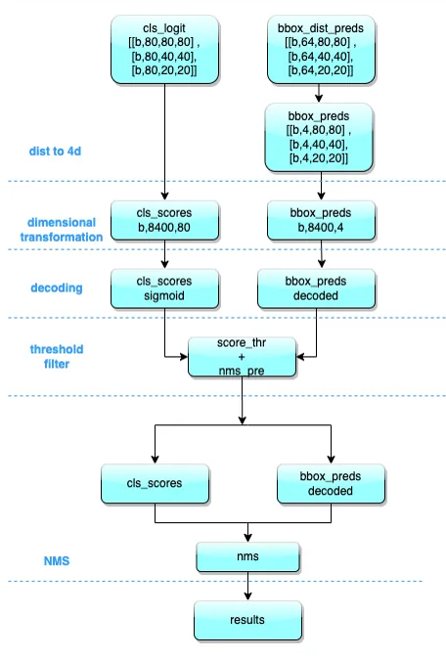
Figure 2.2 Inference process.
Decoding bounding box: Integrate the probability of the distance between the centre and the boundary of the box into the mathematical expectation of the distances.
Dimensional transformation: The outputs are three feature maps. A total of 6 classification and regression different scales of feature map are output by the head module. The three different scales of category prediction branch and bbox prediction branch are combined and dimensionally transformed.
Scale restoration: The classification prediction branch utilizes sigmoid calculations, whereas the bbox prediction branch requires decoding to xyxy format and conversion to the original scale of the input images.
Thresholding: Iteration through each graph in the batch.
Reduction to the original image scale and NMS: Reusing the parameters for pre-processing, the remaining bboxs are first resized to the original image scale and the NMS is performed

Decoding bounding box: Integrate the probability of the distance between the centre and the boundary of the box into the mathematical expectation of the distances.
Dimensional transformation: The outputs are three feature maps. A total of 6 classification and regression different scales of feature map are output by the head module. The three different scales of category prediction branch and bbox prediction branch are combined and dimensionally transformed.
Scale restoration: The classification prediction branch utilizes sigmoid calculations, whereas the bbox prediction branch requires decoding to xyxy format and conversion to the original scale of the input images.
Thresholding: Iteration through each graph in the batch.
Reduction to the original image scale and NMS: Reusing the parameters for pre-processing, the remaining bboxs are first resized to the original image scale and the NMS is performed
Input Image
Backbone
Backbone
Backbone
Neck
Neck
Neck
Head
Head
Head

Figure 2.3 Model layer Network

Backbone Network: This is component is the foundation of the framework. It uses a ResNet-50 deep convolution neural network (CNN) to extract features from the input image.
Neck Network: This component connects the backbone network to the head network. Its role is to reduce the size of the feature map and increase the resolution of the features. The neck network is designed to find a balance between accuracy and speed, making YOLOv8 both fast and efficient.
Head Network: This is the component that predicts the class and location of objects in the image. It uses anchor boxes to estimate the object location and class scores. The head network is trained to optimize the Intersection over Union (IOU) between the predicted and ground-truth boxes. It also includes the non-maximum suppression (NMS) algorithm, which filters out overlapping bounding boxes and ensures that only the most confident predictions are output.
Model architecture depicts the data flow through the computer vision tasks. It provides layers connections and components.

Results
MRI SCAN
Image Pre-processing
Return
Yes
NO
Tumour exist
Classification

Figure 2.4 Model architecture.

Evaluation metrics.
Evaluation metrics are essential in any computer vision tasks, this is to gauge whether the model is performing well in detecting and classification.
Depending on the specific task different metrics are used. In this proposals these evaluation metrics will be used:
Classification accuracy.
In this project, brain tumours are classified making it perfect for evaluation.
This evaluation metric takes the percentage of correctly classified images over the total number of images in the test dataset.
Formula:
Accuracy = (correctly classified samples) / (Total samples)
Precision, recall and F1-score.
These evaluation metrics are used for task that does object detection and instance segmentation.
Precision. The ratio of true positive prediction to the total number of positive predictions made by the model.
Formula:
Precision = true positive/ (true positive + false positive)
Recall. The ratio of true predictions to the total number of ground truth positive samples.
Formula:
Recall = true positive / (true positive + false negative)
F1-score. The harmonic mean of precision and recall, providing a balance between the two metrics.
Formula:
F-score = 2 * (precision * recall) / (precision + recall)

3.6 Quantitative and Qualitative analysis
In this section, analysis of the dataset used in the proposed system is done. How the different techniques for transforming data to meaningful information of training the model is done.

3.6.1. Quantitative Analysis.
Quantitative research is used because it provides a systematic, empirical, and objective approach to measuring and analysing data.
The goal of quantitative research is to understand the relationships between variables and to make inferences about the underlying phenomena being studied.
In the context of the brain tumour detection and classification, quantitative research is used to collect and analyse data on the presence of tumours or not. The data collected include brain magnetic image resonance images. This data is then used to train deep learning algorithms, such as convolutional neural networks (CNNs), to detect the tumours.
The use of quantitative research in the brain tumour detection and classification model allows for the development of a data-driven, evidence-based solution for detection and classifying tumours. It provides a rigorous and systematic approach to analysing data, which helps to reduce the risk of bias and increase the accuracy of the predictions. By using quantitative methods, the proposed system can provide a more reliable and objective approach to detecting and classification of brain tumours, compared to traditional expert-based systems.

3.6.2 Qualitative analysis.
The dataset obtained to train the model was acquired from a public source, therefore, analysing the quality of the data is fundamental. In the proposed model, Peak signal to noise (PSNR) is used to evaluate the performance of the de-noising technique by measuring the quality of the de-noised image. Peak signal to noise ratio is the ratio between the maximum possible power of an image and the power of corrupting noise that affects the quality of its representation. The larger the value of PSNR, the more efficient a corresponding compression or filter method.
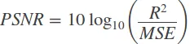
Where, R represents the maximum range of the data. For an image, which is usually 8 bit, the maximum value is 255 while the minimum is 0. Then the value of R is their difference, that is, 255. PSNR is always define in decibels (db) and hence we take the logarithm of the ratio.

Chapter 4

4.1 System design and Analysis.
In this subsection process, how the users will interact with the system and the tools used to achieve the objectives.

4.1.1 Use cases.
The diagram below shows how the users will interact with the system.
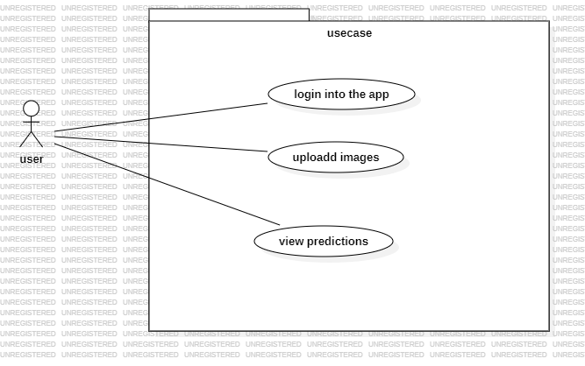
Figure 2.5 use case diagram.
This interaction happens only in two pages the log in and the main page.

4.2.1 Class diagram.
Class a type of unified modelling language diagram that represents the structure of a system by illustrating the classes, their attributes, methods and relationship between classes. The type of relation is association of different classes are represented below. The user class is directly associated to the prediction class.
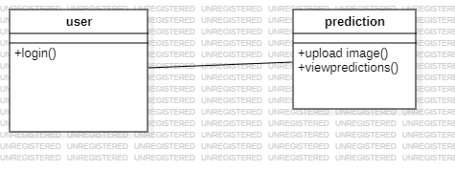
Figure 2.6 class diagram.

4.2 Tool and software requirements.

- Matplotlib. This is a plotting library for creating visualization it will be used to analyse the results of different techniques like histogram equalization .
- Numpy. It is a fundamental library for scientific computing, it provides support for large, multi-dimensional arrays and matrices, along with a collection of high level mathematical functions to operate on these arrays.
- OpenCv. It will be used to handle image input or output, image processing and various computer vision task was used in web app for uploading image and converting grayscale to RGB images before the model could perform some predictions on the image.
- Pillow. Used for image processing tasks like opening, manipulation and saving various image file formats.
- Torch. YOLOv8 is implemented using pytorch which is essential for all the deep learning operations, model training and inference.
- TorchVision. This package is for providing utilities for computer visions tasks. It includes datasets, data transformations and pre-trained for object detection.
- Streamlit. This is a framework for deploying web application. It is suitable for deploying deep learning models due to its simplicity.
- MYSQL. This is the database for storing users credentials and predicted brain tumour classes.
- Tensorflow. Used to load the dataset to be used by the model for training, testing and validation.
- StarUml. This is a tool for drawing diargram it is used in the system to draw class diagram and use case diagrams
- Google colab. It was is used to train deep learning models as it provides adequate GPU to faster inferencing. In the proposed system google colab was used hand in hand with anaconda jupyter notebook.
The hardware requirements are; windows 10 or any other operating system with a RAM of 4 or higher, higher RAM will be valuable.

4.3 Functional and non-functional requirements.
Function requirements are essential since it describe system behaviour under specific conditions. These are the functions that are implement to enable users to accomplish their tasks. The functional requirements are:
- Image upload. Users are able to upload the magnetic resonance image for processing.
- The user is able to see earlier predictions of the brain tumours.
Non-functional requirements are requirements that does not relate to functionality but attributes such as reliability, efficiency, usability, maintainability and portability. Non-functional requirements are:
- Security. The system has authentication where the user have to long to assess the system.
- Performance. The model should provide high performance in detection and classification.

4.4 System Design
In this section, logic design will be discussed, how the objectives and working of the system is achieved. How the user uses the system also is shown.

4.4.1 System Architecture.
The diagram below shows how the user interact with the system. The user starts by login into the system, if failed the displays an error prompting the user to enter correct credentials. If the user logins in successfully the is directed to the main page where he/she uploads the image, the embedded computer vison model performs classification on the uploaded image and the user is able to see the results. The user can iterate within the system uploading images and viewing results. Logging out the user is redirected to the login again.

Login
Log out
Upload Image
View results
Stop
Login failed
Figure 2.7 system architecture.

4.4.2 Database Design
The system uses one relational database mysql, the database contain only one table users for storing logins credentials for the users of the system. The table has userid which is the primary key and password which is a unique character. All the parameters are variable characters.
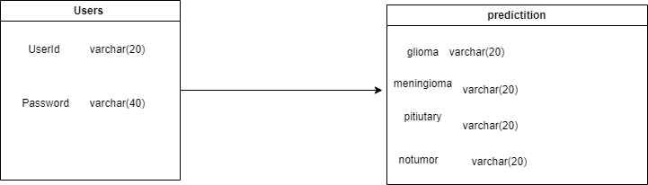
Figure 2.8 database design.

4.4.3 Input Output interface
This is the overall outlook of the application. The application contains 2 pages the login page and the main page. The login page requires the user to enter login credentials and the main page the user can upload an image and view results and also log out of the application where the user will be redirected to log in again into the application.
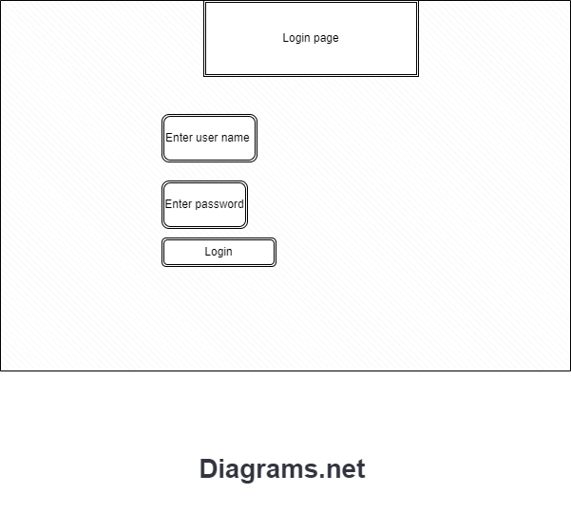
Figure 2.9 login page.
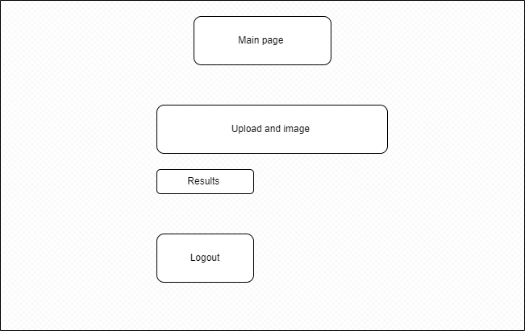
Figure 3.0 main page

Chapter 5

5.1System implementation Testing and Validation.
This is the section where implantation is show via screen shots of the system.
User interface.
The user interface was developed using streamlit web application framework it contains 2 pages the login page and the main page.
Login page.
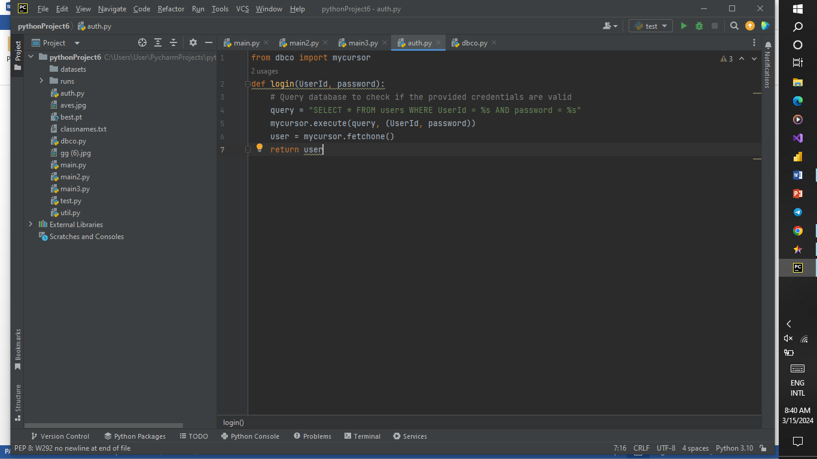

The above screen shot shows the codes for handling login page.
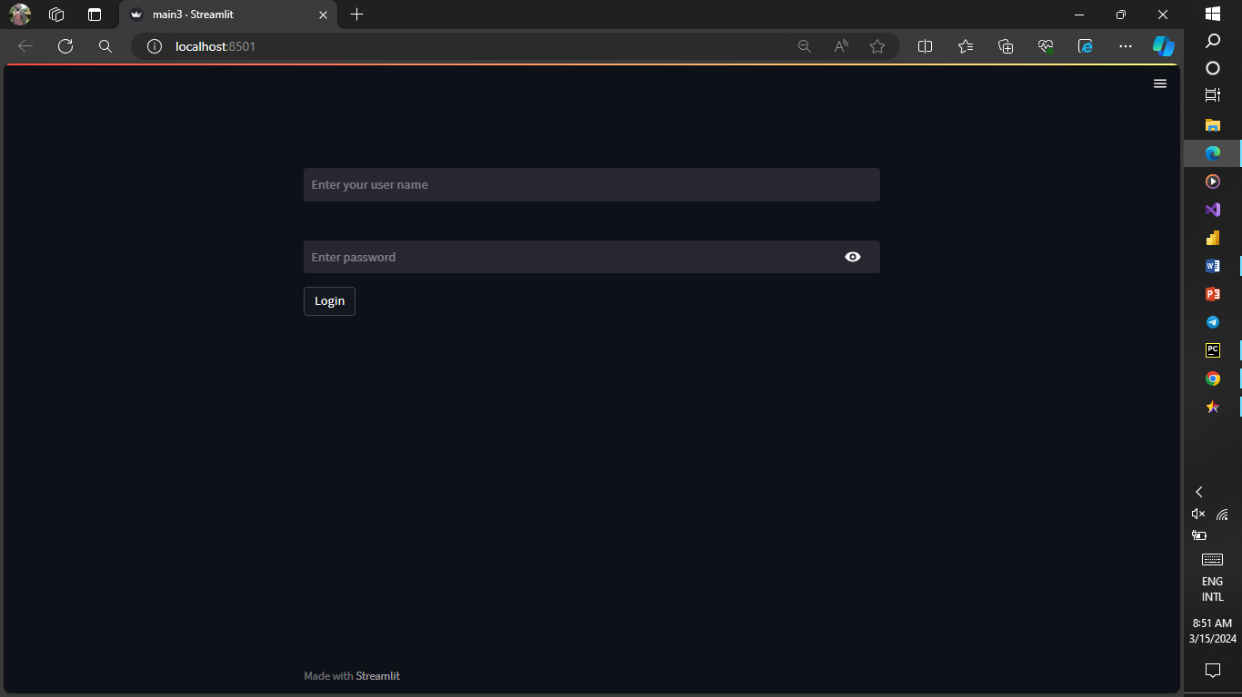

Main page.
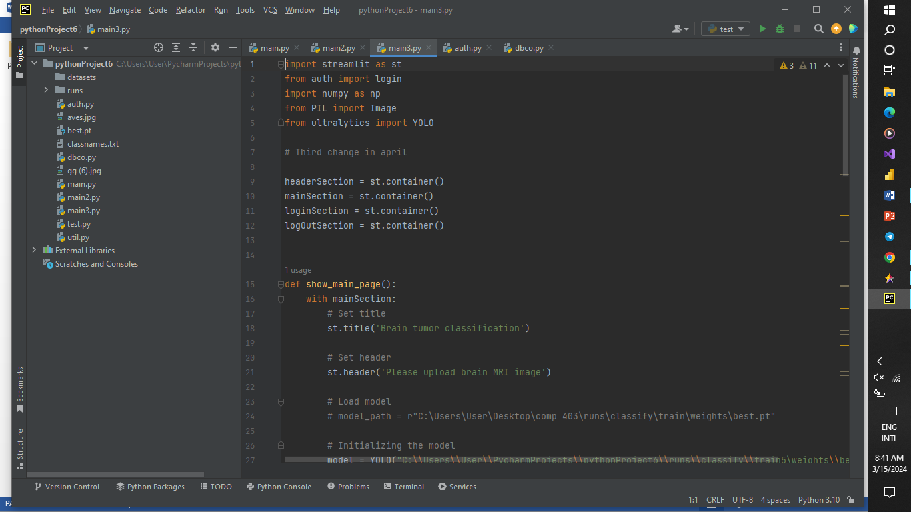
The above is the codes for handling the main page and sessions between logining in the and the main page.
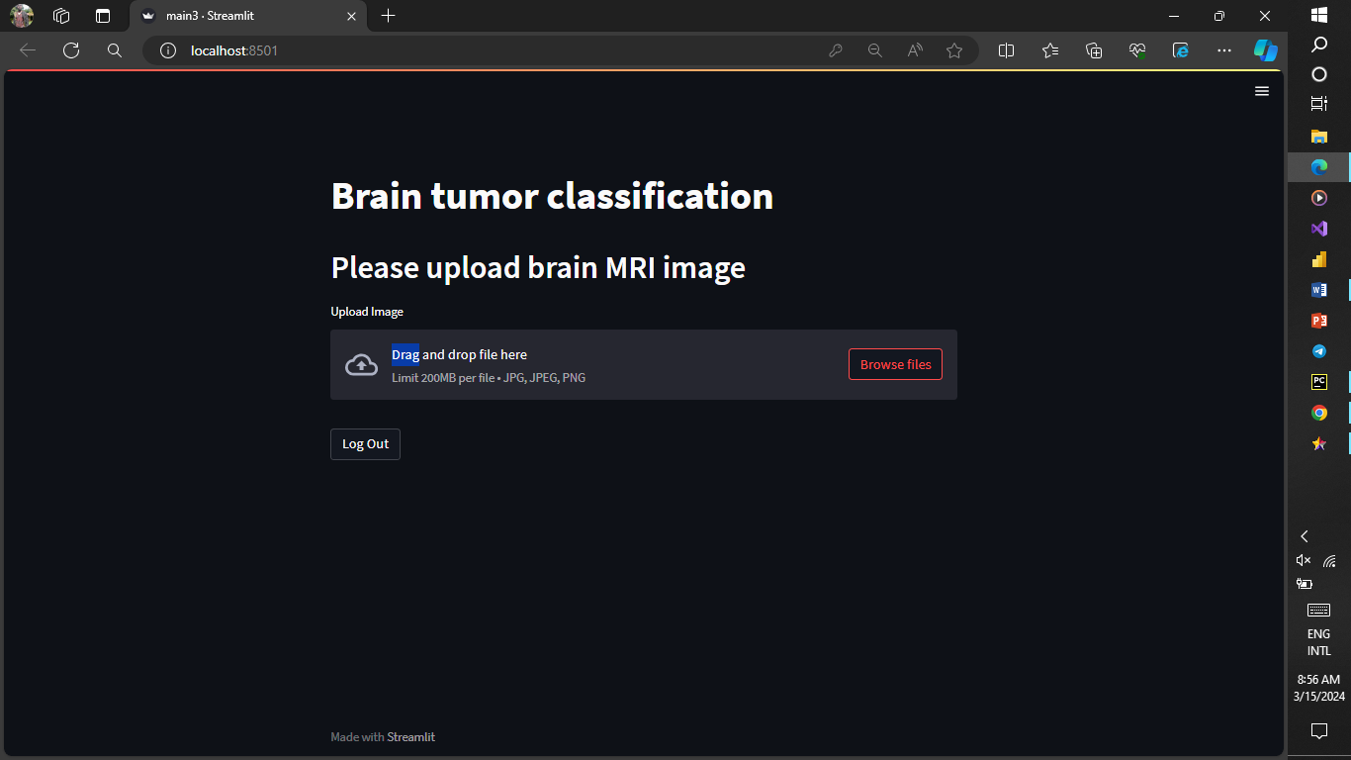
The following snapshots are the performance of the model on test data in the user interface on the class it was trained on:
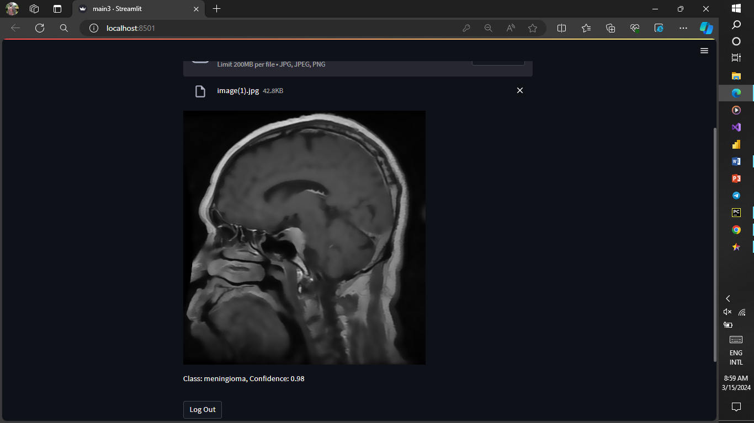
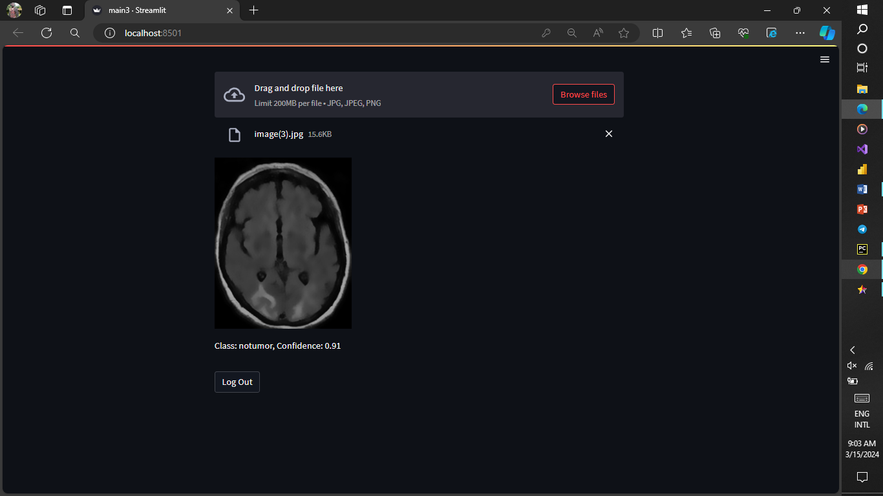
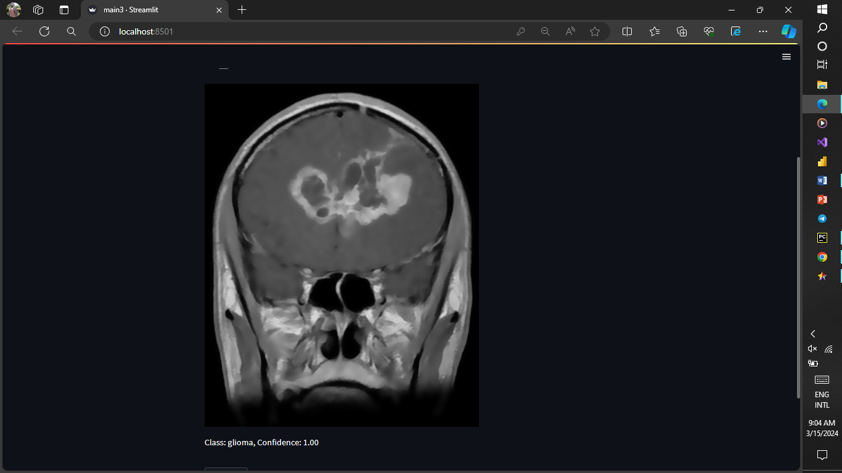
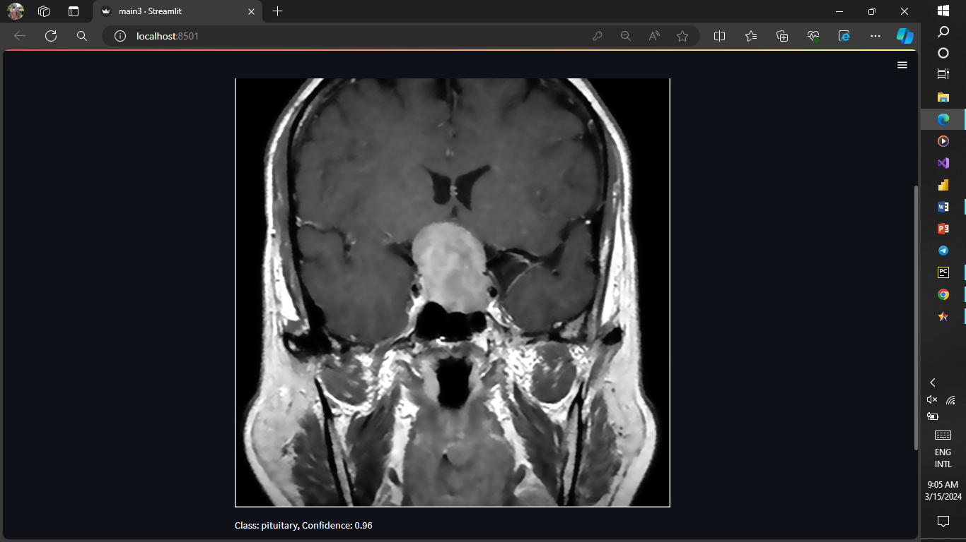
Model development.
The snapshots in this section shows how the model accuracy and development was achieved.
Data preparation.
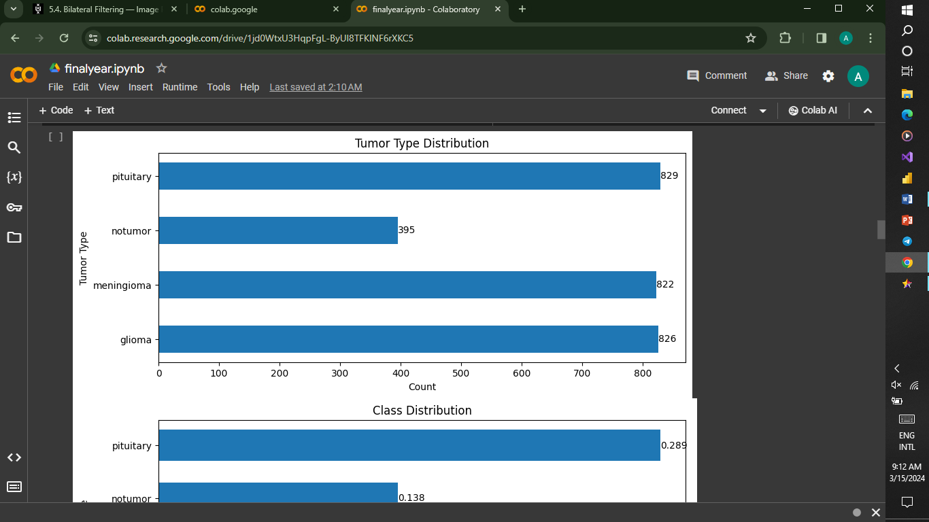
From the snapshot above the classes of the data were balance which makes it good for training the model.
Data pre-processing.

The below screen shot show how histogram equalization was achieved.
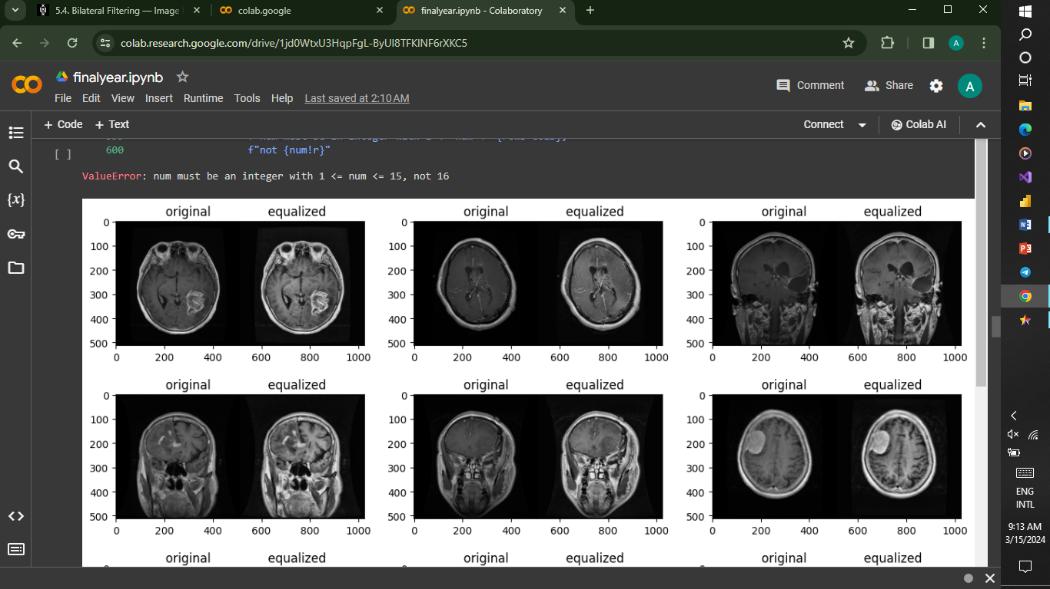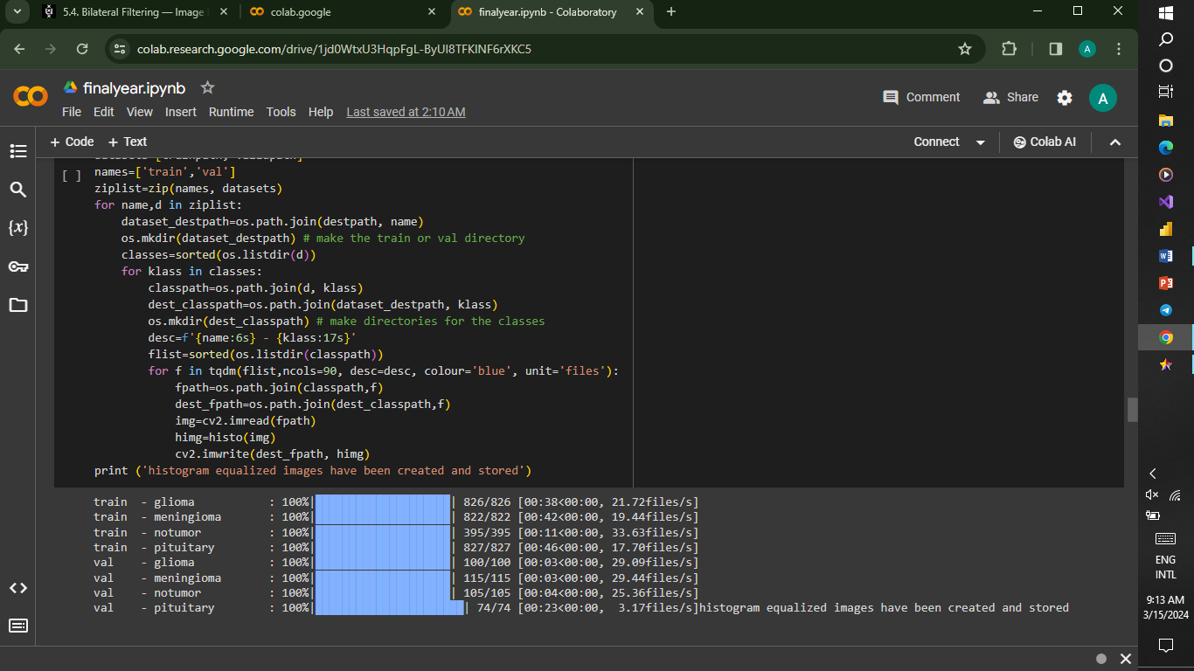
Model Training.
This snapshots show the process of model training.
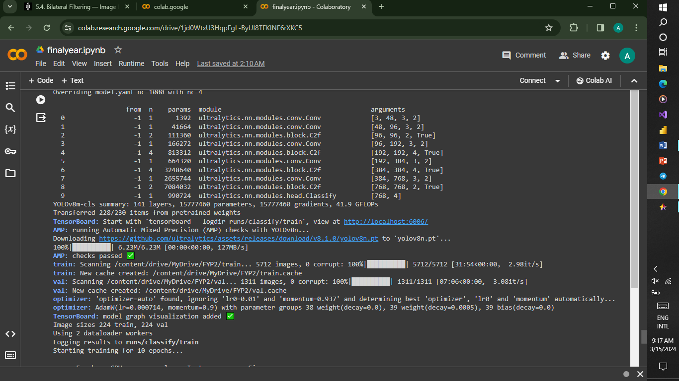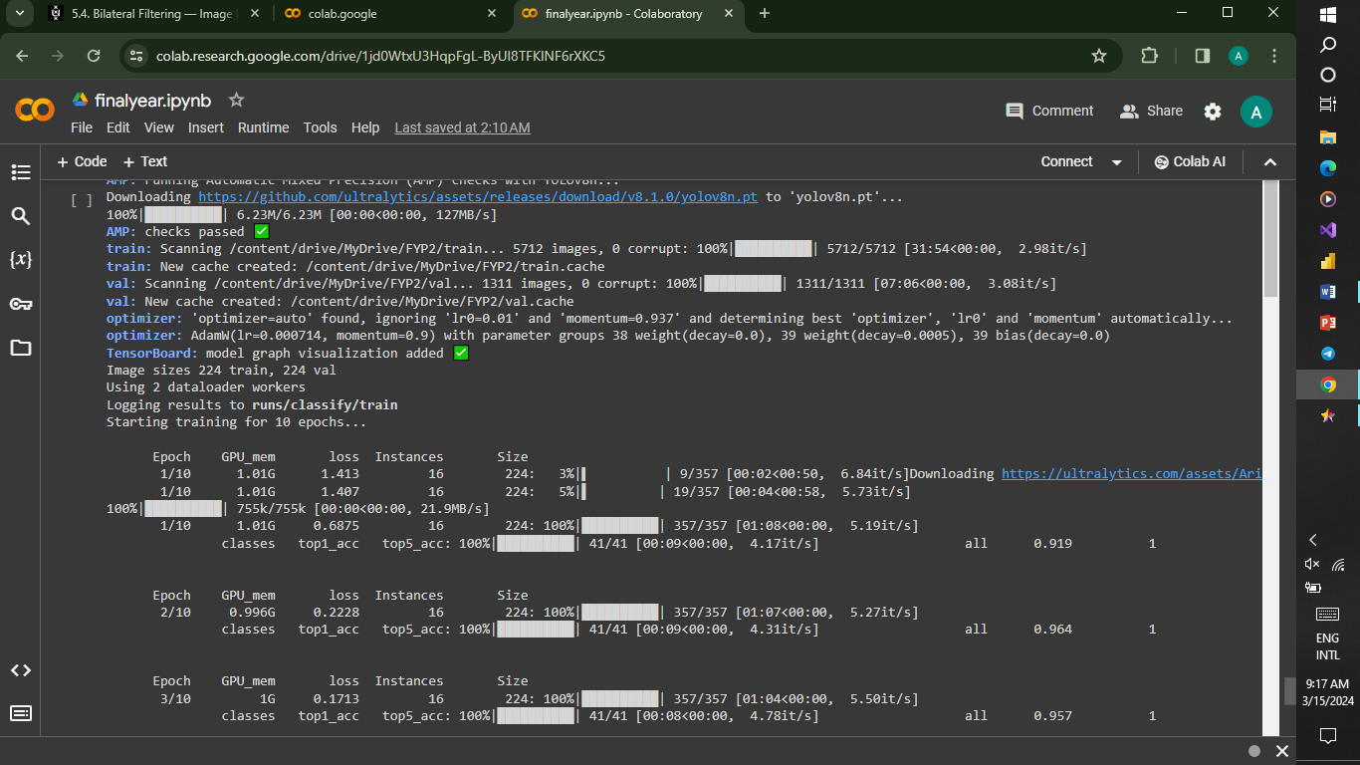
Results.

From the above we can see the accuracy on the correctly classified classes after validation. It accumulates to 99.25% accuracy. Normalize confusion matrix the accuracy will be derived as (98+100+100+99)/4 this is the accuracy of the model. The model was able to classify 100% correctly on meningioma and pituitary while glioma and notumor classes were correctly classified 98% and 99% correctly on the validation data. 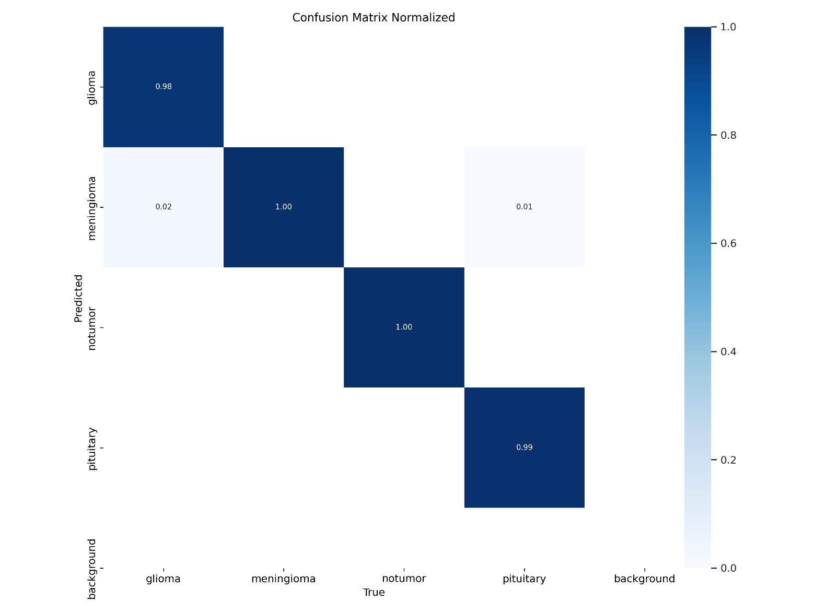
From the figure below contains graph how the training loss and the testing/validation loss as the number pf epochs increase. The validation loss and the training loss kept decreasing as the number of epochs increased. During training of this model only 10 epochs were used why? To prevent overfitting.

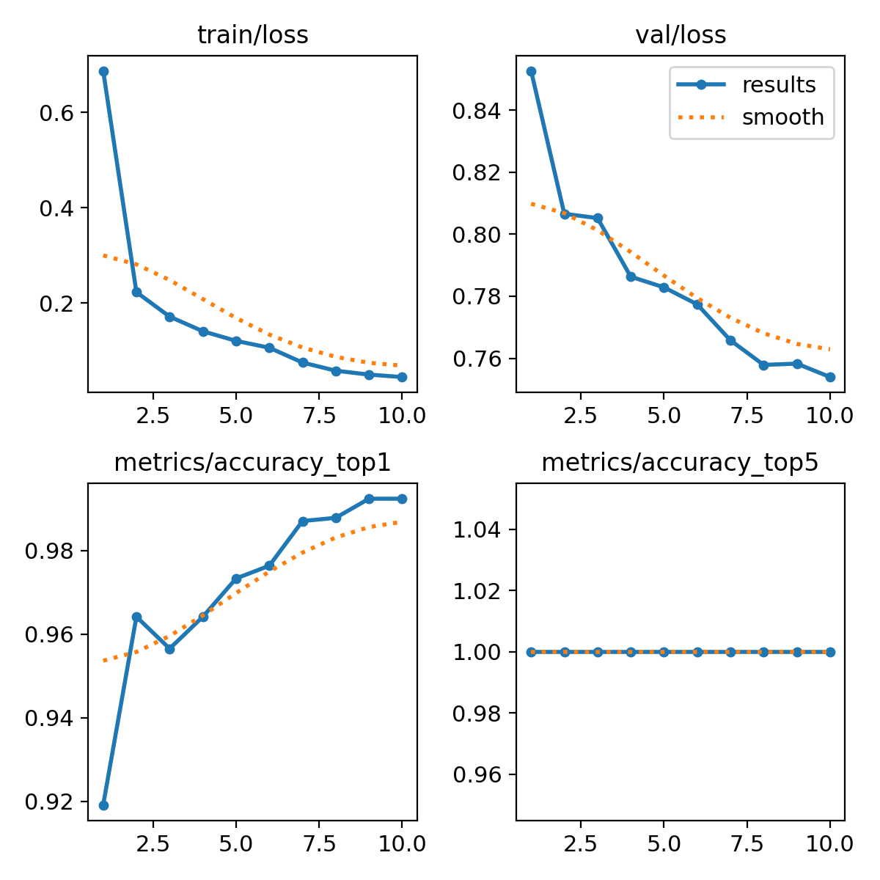

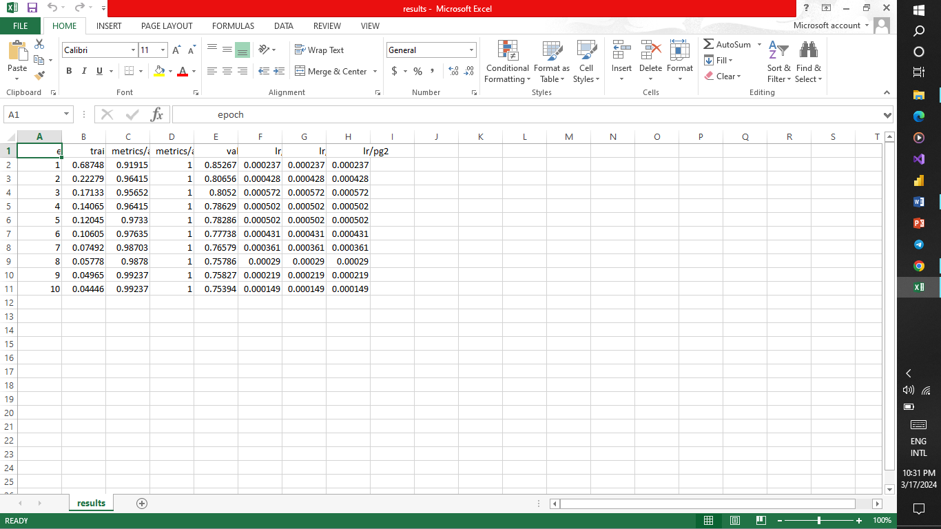

Chapter 6

6.0 Summary, Conclusions and Recommendation.
This is the final chapter in the describing the overview of the system design and the implementation of the system. What challenges encounter on how the challenge was overcome.

6.1 Summary.
The performance of the model was good though there were some challenge. The challenge encounter was data variability in the dataset for training the images. There were a lot of images with poor contrast which hider the performance of the model on test data and also the accuracy of the model in 2 classes that is the glioma and pituitary. To overcome the challenge I used histogram equalization which drove the performance of the model to 99.2% accuracy only on 10 epochs.
The batch number and image size parameters for training the pre-trained model improve the generalization of the image classification and also the accuracy of the model. The above parameters goes hand in hand with the number of epochs finding the right balance yields a better results. When loading the data to yolov8 pre-trained model normalization is not done, do normalization on the data will cause redundancy as yolov8 has a module which does batch normalization the c4f module.
In the use interface the image upload was causing an error but after converting an image to RGB before feeding it to the model yielded a result of predicting the class of the brain tumour. The other challenge was image variability, data variability affects the performance of the model in certain class as the algorithm is not able to identify details such as when the contast is high some details in the image is lost.
In conclusion, achieving better performance of the computer vision model depends entirely on the quality of the data, taking into account the balance of the classes and the variability of the data by using different techniques to deal with the those irregularities in the data. YOLOv8 models in the user interfaces takes RGB images as the inputs therefore it is necessary to convert the images to RGB first before the using the test image for prediction.
Future recommendations, in future research techniques such as hyperparameter tunining, data augmentations should be used during training and testing of the models and also using a high batch size and image size for YOLO models. YOLO models from the above proposed models proofed to be the next thing in computer vision community due to the speed and the accuracy of the model and its smaller size. In this model, medium size pre-trained model was used for future research implement other YOLOv8 model sizes for classification.

Reference
Ansari M.A., Mehrotra R., Agrwal R. 2020. Detection and classification of brain tumour in MRI images using wavelet transform and support vector machine. PP. 1-12.

Kumar A., Ansari M.A., Ashok A.2019 A hybrid framework for brain tumour classification using Grey wolf optimization and multi-class support vector machine. https://doi.org/10.35940/ijrte.C6315.098319

D. J. Hemanth, J. Anitha, A. Naaji, and G. Oana, “A modified deep convolutionals neural networks for abnormal brain images classifications,” IEEE Access, vol. 7, pp. 4275–4283, 2018.

V. S. Narayanan, R. Elavarasan, C. N. Gnanaprakasam, N. S. M. Raja, and R. K. Kumar, “Heuristics algorithms based approach to classify EEG signal into normal and focals,” in Proceedings of the International Conferences on System, Computation, Automation, and Networking (ICSCA), Pondicherry, India, July 2018.

S. L. Marie-Sainte and N. Alalyni, “Firefly algorithms based features selections for Arabic texts classifications,” Journal of King Saud University-Computer and Information Sciences, vol. 3, no. 3, pp. 320–328, 2018.

Goodkin, O.; Pemberton, H.; Vos, S.B.; Prados, F.; Sudre, C.H.; Moggridge, J.; Cardoso, M.J.; Ourselin, S.; Bisdas, S.; White, M.; et al. The quantitative neuroradiology initiative framework: Application to dementia. Br. J. Radiol. 2019, 92, 20190365

S. Rinesh K . Maheswari B. Arthi. P. Sherubha . A. Vijay S. Sridhar T. Rajendran Yosef Asrat Waji 2022. Investigation on Brain Tumour Classification Using machine learning algorithm. https://doi.org/10.1155/2022/2761847

He, M.; Han, K.; Zhang, Y.; Chen, W. Hierarchical-order multimodal interaction fusion network for grading gliomas. Phys. Med. Biol. 2021, 66, 215016.

Ashwini S Shinde, BM Mahendra , Santoshi Nejakar, Santosh M Herur, Nagaraj Bhat. 2022. Performance analysis of machine learning algorithm of detection and classification of brain tumor using computer vision. Volume 173 https://doi.org/10.1016/j.advengsoft.2022.103221

Artzi, M.; Redmard, E.; Tzemach, O.; Zeltser, J.; Gropper, O.; Roth, J.; Shofty, B.; Kozyrev, D.A.; Constantini, S.; Sira, L.B. Classification of pediatric posterior fossa tumors using convolutional neural network and tabular data. IEEE Access 2021, 9, 91966–91973.

Hamza Rafiq Almadhoun ,& Samys S. Abu-Naser 2022. Detection of Brain Tumor using deep learning https://philpapers.org/asearch.pl?pub=275694

Muhammad Aamir, Ziaur Rahman, Zaheer Ahmed Dayo, Waheed Ahmed Abro, M. Irfan Uddin, Inayat Khan, Ali Shariq Imran, Zafar Ali, Muhammad Ishfaq, Yurong Guan, Zhihua Hu 2022. A deep learning approach for brain tumour classification using MRI images. Volume 101.

Muhammad Talo, Ulas Baran Baloglu, Ozal Yildirim, U Rajendra Acharya 2019. Application of deep transfer learning for automated brain abnormality classification using MR images. Volume 54.

Muhammad Sajjad, Salma Khan, Khan Muhammad, Qing Wu, Amin Ullah, Sung Wook Baik. 2019 Multi-grade brain tumour classification deep CNN with extensive data augmentation. Volume 30.

Yang, Y.; Yan, L.F.; Zhang, X.; Han, Y.; Nan, H.Y.; Hu, Y.C.; Hu, B.; Yan, S.L.; Zhang, J.; Cheng, D.L.; et al. Glioma grading on conventional MR images: A deep learning study with transfer learning. Front. Neurosci. 2018, 12, 804

M. Angulakshmi, G.G. Lakshmi Priya. Automated Brain Tumour Segmentation Techniques.
2017 citations 57, volume 27 page 66-77.

